re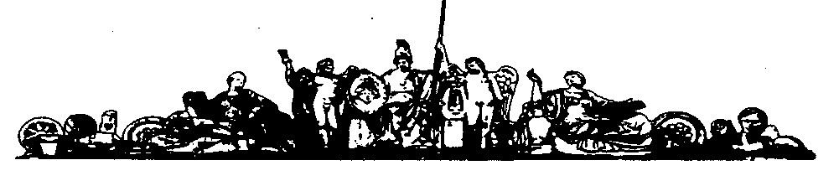
Московский государственный технический университет
имени Н.Э. Баумана

И. А. БЕЛОВА, Е. Н. ШИШКИНА

МЕТОДИЧЕСКИЕ УКАЗАНИЯ
ПО ОБУЧЕНИЮ ЧТЕНИЮ
НАУЧНО-ТЕХНИЧЕСКОЙ ЛИТЕРАТУРЫ
НА АНГЛИЙСКОМ ЯЗЫКЕ ПО СПЕЦИАЛЬНОСТИ
«ПРИБОРЫ И СИСТЕМЫ ОРИЕНТАЦИИ,
СТАБИЛИЗАЦИИ И НАВИГАЦИИ»
ЧАСТЬ 2

г. Москва
2008 г.
УДК 531.01 Англ.
Б43

Рецензент к.т.н. Малахов А. А.
Б43 | Белова И.А., Шишкина Е.Н.  Методические указания по обучению чтению научно-  технической литературы на английском языке по специальности «Приборы и системы ориентации, стабилизации и навигации». Часть 2. – М.: МГТУ им. Н.Э. Баумана, 2008. – 33 с., ил.

Содержат оригинальные тексты, знакомящие студентов с наиболее часто встречающейся терминологией по специальности, а также представляющие интерес с точки зрения грамматики – в них используются распространенные в технической литературе грамматические конструкции и обороты.
Предназначены для студентов младших курсов специальности «Приборы и системы ориентации, стабилизации и навигации».
УДК 541.01 Англ.

МГТУ им. Н. Э. Баумана, 2008

CONTENTS
UNIT 1 | 4
TEXT 1A. THE RATE GYRO | 4
TEXT 1B. FIGURE OF MERIT | 10
UNIT 2 | 11
TEXT 2A. DAMPED OSCILLATIONS | 12
TEXT 2B. RATE GYRO AND GENERAL TESTS | 16
UNIT 3 | 17
TEXT 3A. TEMPERATURE CONTROL FOR CONSTANT DAMPING | 18
TEXT 3B. CROSS-COUPLING ERROR | 21
TEXT 3C. COMPENSATED ROLL PENDULUM | 22
SUPPLEMENTARY TEXTS FOR READING AND TRANSLATION | 26
1. THE EARTH IS A GYROSCOPE | 26
2. RIFLING | 27
3. BIKES, HOOPS AND TOPS | 27
4. SHIP STABILIZERS | 28
5. GYROSTABILIZED CARS | 29
6. BINOCULAR STABILIZER | 29
7. INTEGRATING ACCELEROMETER | 30
8. DIRECTION FINDERS | 31
9. REMEMBER GYROSCOPICS | 32
QUESTIONS AND PROBLEMS | 32

UNIT 1

Essential vocabulary.

drift,n – снос
random torque,n – случайный момент
reading,n – показание
reference line,n – линия условного уровня, контрольная линия, опорная линия
spring member,n – упругий элемент
stall torque,n – опрокидывающий момент
stretch,n – вытягивание, растягивание, удлинение
be subjected to,v – подвергаться чему-либо
consume,v – потреблять
extend,v – расширяться
imply,v – предполагать, подразумевать, заключать в себе, значить
refer to,v – ссылаться на
restrain,v – сдерживать
bilateral,adj – двунаправленный, двухсторонний
captive,adj – дочерний, подчиненный
for some comparison – для некоторого сравнения
in conjunction with – в связи с, в сочетании с

Text 1A. The Rate Gyro
The vertical and directional gyros are commonly called displacement gyros. These units measure the angular displacement or rotation of a base surface about some stabilized reference line. Control systems used in conjunction with displacement gyros utilize a torque in – precession out relationship. Various controlling torques are applied to cause the stabilized reference line to precess to a particular position. The torque in – precession out relationship determines the quality of the gyro. Random torques produce unwanted random drifts which affect the precision of the gyro.
If you started with precession or angular rate, you could figure out the applied torque. This implies an interesting concept: if a gyro is subjected to any angular rate, a torque about the quadrature axis will be developed. In other words, a gyro is a bilateral device, as a torque input produces an angular rate output (torque in – precession out), and an angular rate input produces a torque output (precession in –torque out). The rate in – torque out relationship is the basis of the rate gyro (Fig. 1).
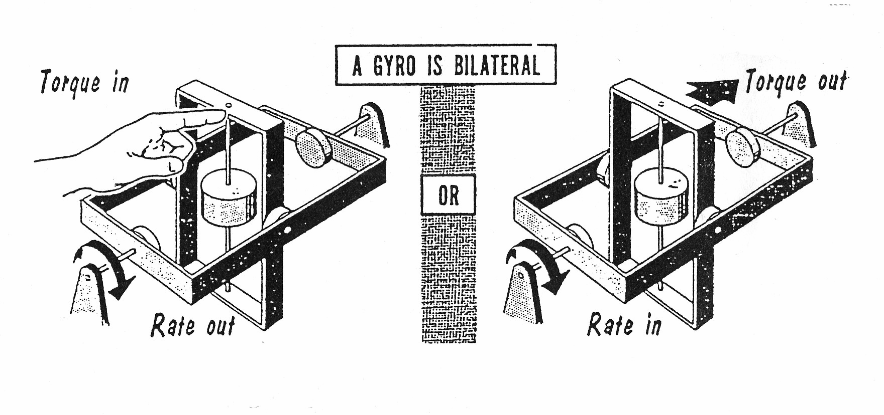
Fig. 1.
Consider what would happen to the single-degree-of-freedom gyro if subjected to an angular rate about the quadrature axis. The indicated torque would be developed about the gimbal axis. Instead of permitting complete freedom of movement about the gimbal axis, let us connect a spring member (as shown) between the gimbal and the base. See Fig. 2.
The gimbal rotates about the gimbal axis until the torque developed by the extending spring just balances out the gyroscopic torque developed from the input angular rate.
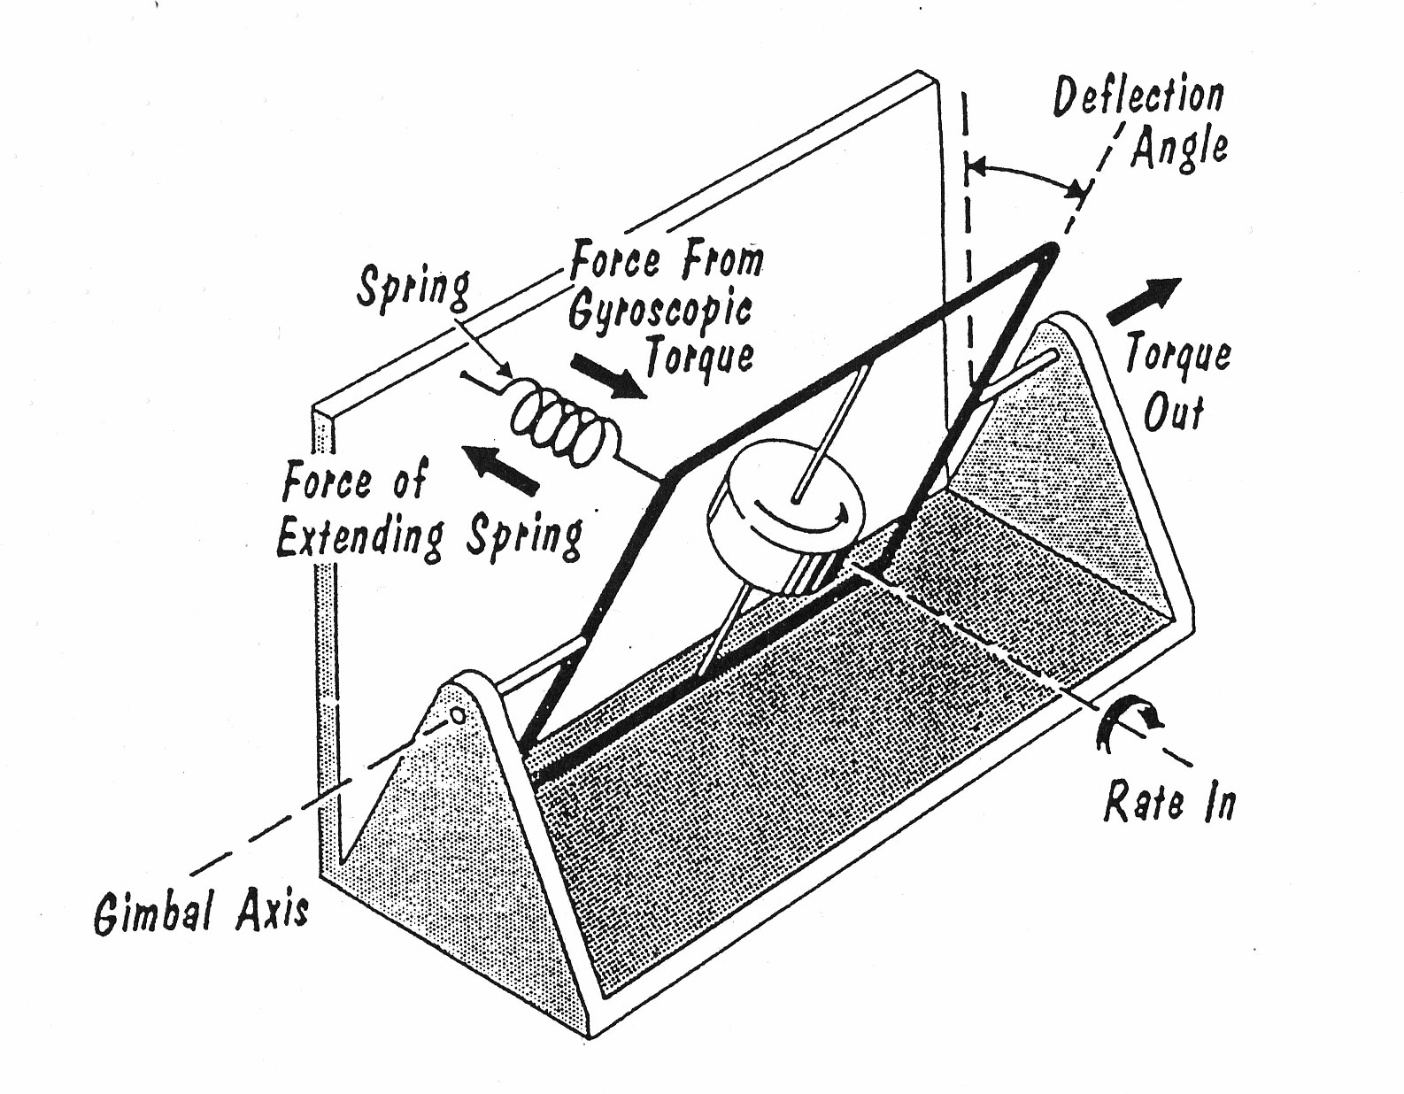
Fig. 2.
The force developed by a spring is proportional to the stretch (compression). If the direction of the input angular rate is reversed, the gimbal will rotate against the spring in the opposite direction. Therefore, the angle of rotation about the gimbal axis is a measure of the input angular rate. If a pickoff is arranged to measure this gimbal angle, the pickoff reading will be proportional to the input angular rate.
The result is a gyro which instead of measuring displacement from a reference line measures the rate-of-change of displacement about a line (or axis). This is a rate gyro. Because the gimbal of the rate gyro is restrained by a spring, it is sometimes referred to as a captive gyro. Basically, the introduction of a spring member changes a displacement gyro into a rate gyro.
Rather large torques are developed in a rate gyro. A reasonable value of H for a rate gyro is about 5 x 105 dyne-cm²/sec. If this unit is used to measure a rate of 100 deg/sec, a gyroscopic torque of about 13 oz-in is developed. A rate gyro rotor developing this torque would be about 1¹/₂ in diameter by about 1¹/₂ in long, and consume about 7 watts of power. For some comparison, a standard servo motor of about the same size has only 0.1 the stall torque (1.4 in-oz) for about twice the power input (12 watts).
The axis about which the spin motor of a rate gyro rotates is called the spin reference axis (SRA). The axis about which the gimbal rotates is called the output axis (OA). The axis about which the rate gyro measures angular velocity (angular rate) is called the sensitive axis (SA) or input axis (IA). See Fig. 3.
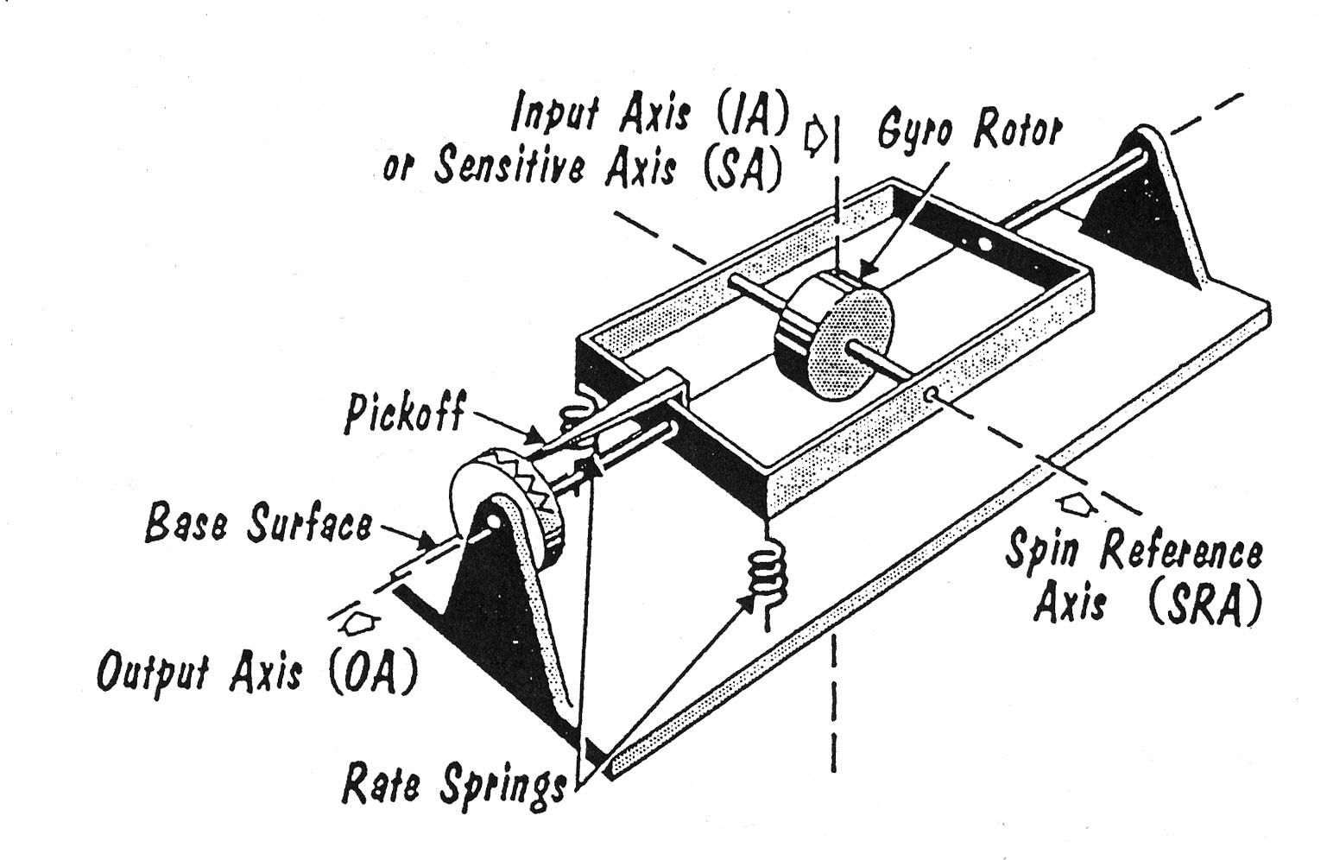
Fig. 3.

EXERCISES

EX.1. Complete the chart and translate the words. If necessary consult the dictionary.
Nouns | Verbs | Adjectives
 | depend
precision | –
 |  | directional
 | displace | –
angle | –
(3 variants) | relate
 |  | various
 | apply
reference |  | –
(2 variants) | produce
precession |  | –
 | develop | –
basis
freedom
 | move | –
 | compress
comparison
rotation
 | read
frequency | –
 | connect

EX.2. a) remember the words which have the same forms in different parts of
speech. Which are they: nouns – (n.), verbs – (v.), adjectives – (adj.)? The
first is given.
EX: measure (n.) – measure (v.);
subject (n.) – subject … ; reverse (adj.) – reverse … ; direct (v.) – direct … ; cause (n.) – cause … ; drift (v.) – drift … ; complete (v.) – complete … ; result (n.) – result … ; constant (n.) – constant … ; figure (n.) – figure … ; input (v.) – input … ; start (n.) – start …
- which of these words have different stresses when being a noun and a verb?
- which letter should be changed in the noun “effect” to make it a verb?

EX.3. Look through the text and find:
a) conditional sentences (6). Define their types. In which of the sentences is Subjunctive Mood used? Translate them;
b) a time clause. Why isn’t future tense used here? How will you translate the time clause? In which other types of clauses can’t we use future tense? Give some examples;
c) imperative constructions (2). What other ways of expressing suggestions and orders do you know? Do you know how to form a negative suggestion or order?

EX.4. In each of the following sentences find the predicate and define the tense of
the verb and the voice (Active or Passive). Fill in the table. Translate the
sentences.
1. At the same time the pickoff is generating a signal which is being applied to the torquer about the output axis. 2. The term threshold rate has been used here to describe the process. 3. The problem of relating one set of angles to another is usually referred to as coordinate transformation and is most often accomplished by using resolvers in conjunction with a simple computer. 4. If the antenna is being stabilized hermetic integrating gyros (HIGs) directly on the antenna structure correcting signals are commonly introduced through the HIGs torquer. 5. In some designs the pickoff and torquer have been combined into a single unit. 6. The roll gimbal is attached directly to the airframe, and is stabilized about the roll axis by the roll gyro motor. 7. With the signal at 0, the object has stopped rotating in space, or has been stabilized. 8. The resistance to the gimbal rotation depends directly upon the viscosity of the damping fluid and the velocity with which the gimbal rotates. 9. When the car turned, the precession torquers of the two gyros opposed each other. 10. This signal exactly as when the table was rotating in inertial space drives the servo motor. 11. The integrating gyro will probably require an amplifier between the pickoff and torquer, and temperature control will always be involved. 12. Many years ago, gyro compasses were built for the Navy. 13. We have been working with forces of extremely small magnitude.

EX.5. Define the type of Conditional Sentences and translate them correctly.
- If we sum up bits of angular velocity over a time span, we get the total angle travelled. 2. Even if there were no angular velocity about the input axis the gimbal would rotate about the output axis and the output axis pickoff could not tell whether the gimbal displacement occurred from displacement about the input axis or from the electrical torquer. 3. If the table begins to rotate, the gyro sensing the rotation will begin to precess, resulting in an output signal. 4. If it were not for ground based navigation aids, only a few brave individuals would consider flying any distance. 5. If the air mass were also moving the ground speed might be quite different. 6. If we had used the simple accelerometer integrator scheme discussed so far, all we would have been able to do is find out the velocities and distances travelled along the flight path of the missile. 7. If the table is level or horizontal about the axis, there is no problem. 8. If we could find a way of monitoring the accelerations along each of these three inertially stabilized coordinates, we would know at any time, where the missile is in space. 9. If we simply mount the stable platform on the aircraft or missile and mount the accelerometers on each of the stabilized axes we can get outputs which will at all times show where our missile is in space. 10. Unless the test is being conducted at the North Pole, a gyro the pickup of which does not show an apparent drift is stuck or it is drifting opposite to the Earth’s rate.

EX 6. Find the verbs in Subjunctive Mood and translate the sentences.
- For example, it may be necessary that the antenna be made to scan about some fixed line. 2. If you weigh 150 lbs on the Earth, you would weigh 4,184 lbs on the Sun, 57 lbs on Mars and 128 lbs on Venus. 3. Fig. 3 shows how this accelerometer system might be used to measure the distance travelled by an automobile travelling in a straight line. 4. The second platform is also gimballed so that its orientation could be modified as a result of heading and vehicle velocity. 5. There would be no Coriolis problem if the Earth were not rotating, but it is. 6. Suppose for a moment the Earth were not rotating. 7. At the rate of 0.01 deg/hr it would take more than 4 years to make 1 rev. 8. Ideally, the structure of the gyro is balanced so that all weights act as if they were concentrated on the point determined by the intersections of the spur axis, sensitive axis and output axis. 9. Preloading consists of applying constant forced pressure to the wheel structure, much the same as if there were a spring between the case and the wheel.

EX.7. For discussion.
- Which types of gyroscopes belong to the group of displacement gyros?
- What kind of a unit is a displacement gyro?
- Explain: a gyro is a bilateral device.
- What are the principal parts of a rate gyro?
- Which relationship is the basis of a rate gyro?
- Sketch a rate gyro and label the three axes.
- Speak on the differences between displacement and rate gyros.

EX.8. Learn the words and word combinations from the text and check yourself.
Translate the phrases:
angular displacement, stabilized reference line, spring member, gimbal axis, torque output, random torque, pickoff reading, for some comparison, quadrature axis, bilateral device, gimbal angle, captive gyro, spin motor.

EX.6. Finish the following sentences without looking into the text:
- Unwanted random drifts may affect …
- The basis of the rate gyro is …
- The gimbal rotates about the gimbal axis until the torque …
- The vertical and directional gyros are commonly called …
- If a pickoff is arranged to measure the gimbal angle the pickoff reading will be proportional to …

EX.10. Give definitions to the following notions:
the spin reference; the output axis; the sensitive axis; a displacement gyro; a rate gyro; a captive gyro.

Text 1B. Figure of Merit
Look through the text and say: what is the figure of merit? Time limit 3 min.
Although the user of a rate gyro cannot readily determine the spring constant (K), the manufacturer of the rate gyro will provide the rotor speed (W_{s}) and the figure of merit (f_{m}). The figure of merit is the inertia of the motor about the spin reference axis (I_{s}) divided by the inertia of the gimbal motor about the output axis (I_{o}) and is set by the basic design of the gyro. Note that since I_{s} and I_{o} are expressed in the same unit, while f_{m} has no unit, it is a pure number. Usually, the higher the figure of merit, the more satisfactory is the rate gyro. The user of the rate gyro will usually specify the maximum rate the unit is to measure (W_{i}, in deg/sec). Having set these values, the natural frequency for any particular rate gyro design can be computed from the corresponding equation.

UNIT 2

Essential vocabulary
can,n – чехол, кожух
damped oscillations,n – затухающие колебания
damping,n – демпфирование, затухание
damping factor,n – коэффициент затухания, декремент
dashpot,n – успокоитель, амортизатор, катаракт
gap,n – зазор, промежуток
molasses,n – меласса, черная патока
oscillation ,n– колебание
overshooting,n– отклонение от установленного значения, перерегулирование
piston,n – поршень
viscosity,n – вязкость
creep,v – сползать, ползти
plot,v – составлять план, схему, вычерчивать диаграмму, график
seal,v – изолировать
instantaneous,adj – мгновенный, моментальный
oddy,adj – случайный, блуждающий
tolerable,adj – допустимый

Text 2A. Damped oscillations
Let us look at the weight on the spring. If we pull the weight down and then release it, it will oscillate continually overshooting the 0 position for some time before the oscillation dies away. Then the instantaneous position for the weight can be plotted against time. This is called a damped oscillation. The oscillation dampens out (stops) after a period of time. If this weight-spring system is put in a fluid, called a damping fluid, the weight is displaced and then released, and the weight will creep back up to the 0 position without overshooting, providing the damping fluid is heavy enough.
For example, imagine that the fluid were molasses. The instantaneous position of the weight can be plotted against time.
A numerical value, called damping factor, and given the Greek symbol of zeta, is assigned to the amount of damping. The basis of the number scale is a value called critical damping. This is the lowest value of damping (zeta equals 1) that does not give an overshoot of the 0 position. If the damping is decreased (zeta is less than 1), there are one or more overshoots of the 0 position. A system with a damping factor less than 1 is called an underdamped system.
When the damping is increased above critical (zeta is greater than 1), there are no overshoots of the 0 position. Such systems are called over-damped.
The damping factor most often used is 0.7. This is a particular underdamped case where only one overshoot is present and where the system settles out at the final value before it would with any other value of damping: either greater or less than 0.7.
In a rate gyro, damping is required between the gimbal and the case (Fig. 4) to reduce similar oscillations. In some designs, the damping is obtained by means of a dashpot – a device which looks very much like a piston moving in a cylinder filled with fluid or air. Electric currents called oddy currents are sometimes used for damping. Generally, the entire case is filled with fluid.
Since the gyro could hardly run up at high speeds in viscous fluids required for damping, the gimbal holding the wheel is frequently made like a can and sealed. The gimbal can be a cylinder rotating about the outer axis, concentric with the outer case, which is also made like a cylinder. Using this construction, the damping is made larger by either increasing the viscosity of the damping fluid, or by decreasing the space between the two cylinders. The space between the two cylinders is called the damping gap.
Fluid damping would be no problem if the rate gyro were to be used at only one temperature. But this is not usually the case. In many military applications, for example, the gyro must perform properly over a range of temperatures from -60 deg to +200 deg F. The damping fluid commonly used in the rate gyro, silicone oil, has about 15 to 1 change in viscosity over that temperature range. This means that if the damping were 0.7 at +200 deg F, the damping would be 10.5 at -60 deg F. Such a wide variation in damping is usually intolerable.
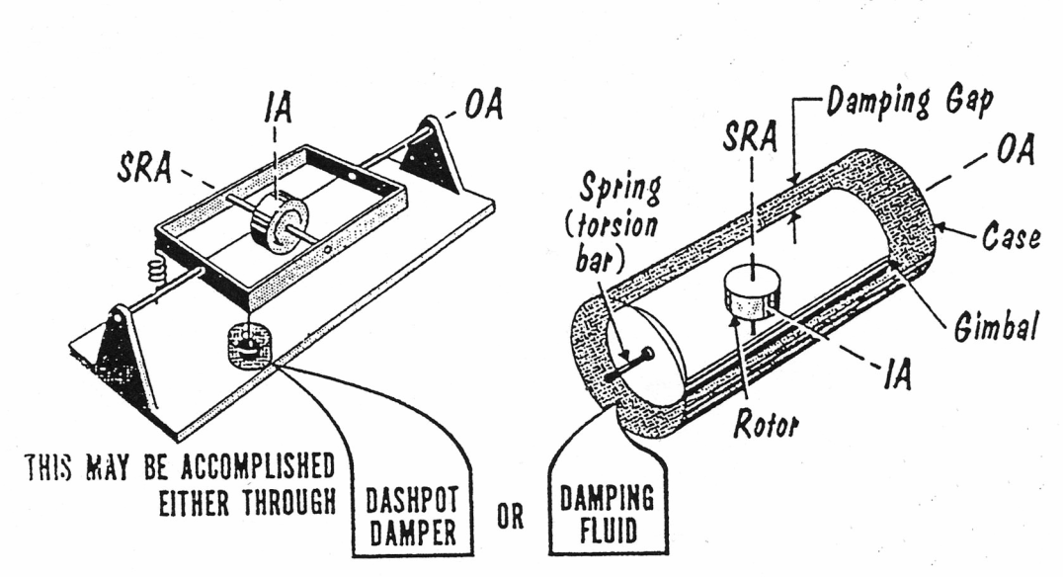
Fig. 4.

EXERCISES

EX.1. Complete the chart and translate the words.
Nouns | Verbs | Adjectives
 | dampen | –
instant | –
 | imagine
 | – | viscous
number |  | (2 variants)
tolerance
 | use
 | weigh
rotation
meaning
(2 variants) | design | –

EX.2. Form opposites to the following words with the help of suffixes and put them
into the right column.
increase, interesting, complete, tolerable, possible, wanted, connect, use, developed, reasonable, sensitive, desired, continuous, common, limited, normal.
de- | in- | im- | mis- | un- | dis-

EX. 3. Look through the text and find:
- all the sentences with gerunds (3);
- passive constructions (21);
- sentences where Participles II are used as attributes (13);
- an example of an equivalent of the modal verb “must”. Which other equivalents of the modal verbs do you know? Use them in your own sentences;
- what’s the meaning of “providing” in the last sentence of par. 2? Can this word have another meaning? Do you know what it is? Give an example in a sentence of your own.

EX.6. Find all the ing-forms in the following sentences. Which of them are
participles and which are gerunds? Find two sentences with Absolute Participle Constructions.
- The fluorocarbons used have densities almost twice great as water. 2. The only true three axes stable platform under such conditions is the equipment being slaved to the gyros. 3. The problem of relating one set of angles to another is usually referred to as coordinate transformation, revolvers in conjunction with a simple computer being often used. 4. By choosing the proper pickoffs for the various axes, or by using a small computer to set up the required relationships, the antenna can be slaved from the gyro. 5. Slaving single equipment such as antenna to two gyro references becomes complicated, there being some differences in gymballing sequences. 6. The electrical pickoff frequently employed is a variation of the microsyn torquer explained earlier. 7. An antenna stabilized by rate or integrating gyros can also be considered a stable platform. 8. When the voltage gets to a selected level indicating a troublesome level of rate-of-charge of airspeed the pitch erection cutout relay is energized, removing the output of the pitch pendulum from the input to the pitch erection amplifier. 9. By controlling heading and speed, the navigator knows that he will reach his objective within a certain amount of time. 10. An airplane pilot cannot always afford the luxury of seeking his checkpoints. 11. The car’s odometer measures distance by counting wheel rotations. 12. Getting distance from acceleration is schematically shown in Fig.2.

EX. 4. Translate the following sentences paying attention to various functions of
the verbs: “have”, “be”, “do”. Find examples of the use of the verbs “have” and “be” as equivalents of the modal verbs. Which of the sentences are emphatic ones due to the use of the verb “do”.
- The integrating gyro reference can be used in exactly the same manner as is the conventional displacement gyro. 2. If the aircraft were to simply pitch everything would be fine since the two elevation axes pickoffs would measure exactly the same angle. 3. Because the antenna is gimballed with the elevation axes connected to the airframe pitch axis, the antenna elevation pickoff does measure the true aircraft pitch angle. 4. The second method of stabilizing the antenna is to mount it on a stable platform. 5. Because of its physical construction, the integrating gyro makes a much more sensitive rate gyro than does the conventional spring restrained rate gyro. 6. The operator would have to be right on his toes to turn it off in time. 7. This servo motor does not torque the vertical gyro as does the roll centering servo motor used on the three gimbal platform, because the vertical gyro rotor has freedom about the inner role axis. 8. Many years ago, gyro compasses were built for the Navy that had to have drift rates in order of 0.02 to 0.4 deg/hr. 9. One way to do this is to use a servo system to reproduce a shaft angle which is proportional to airspeed. 10. Suppose an angular velocity is applied on the gyro about the yaw axis of the aircraft. 11. One of the difficult problems that had to be solved was how to detect the position of the spinning sphere without introducing frictions or torques. The answer was to use capacitive rather than inductive pickoffs.12. The pickoffs on the gyros are not generally measuring the same angles as are the pickoffs on the stabilized equipment. 13. The other reason is that the gyro does indeed integrate the input angular rate.

EX. 5. For discussion.
- What is a damped oscillation?
- What is the significance of a damping factor?
- Explain: overdamped, critically damped, underdamped?
- What can a gimbal holding be?
- If you wanted to compensate a fluid-filled rate gyro so that damping remained constant with the temperature and you wanted to control the damping gap, which way would the gap have to change when the gyro got cold? When the gyro got warm?

EX.6. Translate the following abstracts from the text without using the list of vocabulary.
- … change in viscosity over the temperature range.
- … it will oscillate continually overshooting the 0 position for some time …
- a numerical value… is assigned to the amount of damping.
- fluid damping would be no problem …
- … the damping is made larger by either increasing the viscosity of the damping fluid, or by decreasing the space between the two cylinders.
- the damping is obtained by means of dashpot …
- the gimbal can be a cylinder rotating about the outer axis, concentric with the outer case …
- when the instantaneous position for the weight is plotted against time …

EX.7. Give definitions to:
damped oscillation; damped factor; critical damping; dashpot; damping gap.

Text 2B. Rate Gyro and General Tests
Look through text 2B and speak on the general gyro tests. Use the
following questions as a plan:
- what is usually checked in these tests?
- what is a controlled rotating table?
- what is an oscillating table used for?
- which other tests can be performed on gyros?

The most important parameter checked on rate gyros is the accuracy of rate measurement. A controlled rotating table (a rate table) is used to calibrate rate gyros. This is done by mounting the gyro on the table with the input axis parallel to the axis of rotation. Various rates are set into the table and the rate gyro output is measured. An oscillating table is used to measure the natural frequency and damping characteristics of the rate gyro. Generally, this is done by comparing the phase of the gyro output signal with the phase of a velocity pickoff mounted on the oscillating table, as the frequency of oscillation is varied. A phase difference of 90 deg occurs when the table is being oscillated at the gyro natural frequency. A somewhat simpler test is to compare the phase of the gyro output signal with the phase of a position pickoff mounted on the oscillating table. Here, a phase difference of 0 deg is obtained when the table frequency equals the rate gyro natural frequency. The shape of the phase shift versus the table oscillating frequency curve is determined by the rate gyro damping.
These are the main gyro tests. However, gyros are checked for a variety of other things, including pickoff and torquer sensitivity, power consumption, damping control, rotor bearing condition (by determining motor run down time), axis alignment and cross-coupling, sensitivity to angular and linear acceleration and velocity, vertical and directional accuracy, resolution, threshold and hysteresis. Gyros are periodically checked to determine performance under extreme environmental conditions of temperature, humidity, vibration and shock.

UNIT 3
Essential vocabulary:
bellows,n – гофрированная трубка, пневматический амортизатор
blanket,n – покрытие, поверхностный слой, защитный слой
factor,n – множитель, коэффициент, показатель, фактор
housing,n – корпус, кожух
ratio,n – отношение, пропорция, коэффициент, степень
sleeve,n – втулка, муфта, цилиндр, барабан, корпус
contract,v – уплотнять, сжимать, стягивать
eliminate,v – устранять
expand,v – расширять
incorporate,v – соединять, помещать, включать, монтировать
maintain,v – поддерживать
slope,v – наклоняться, иметь наклон
warrant,v – подтверждать, гарантировать
ambient,adj – окружающий
tight,adj – плотный, тугой, посаженный наглухо
back and forth – взад и вперед
conversely – напротив, наоборот
thereby – таким образом, в связи с этим

Text 3A. Temperature Control for Constant Damping
One approach is to operate the gyro at a constant temperature, thereby keeping the fluid viscosity constant. Such gyros incorporate a thermostat set to open above the maximum ambient temperature (see Fig. 5). If the gyro were to be used to +200 deg F, the thermostat might be set to open at +210 deg F. At temperatures below 210 deg F, the thermostat is closed and power is applied to a heating blanket surrounding the gyro. The gyro is then heated until the temperature is high enough to open the thermostat and stays open until the gyro cools down enough to close the thermostat again.
Using such a control, the temperature can be maintained constant within about plus or minus 5 deg F. This variation in temperature is usually small enough to keep the fluid viscosity constant enough for most applications. Damping can be held constant within plus or minus 5 percent of the nominal value. Such heater controls require a lot of power – about 100 to 200 watts-which may not be readily available.
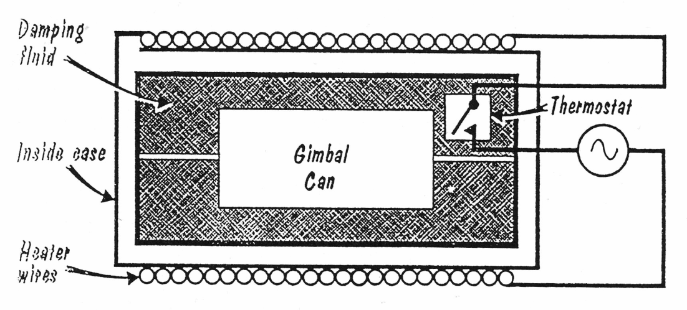
Fig. 5.

A number of mechanical means have been devised to reduce the damping variation with temperature. These are all aimed at eliminating the heater and thermostat. One method makes use of the fact that different materials expand at different rates with temperature. Nylon, for example, expands about 4 times more than does aluminium over the same temperature range. By placing a nylon sleeve over the gimbal and fabricating the housing from aluminium, the damping gap can be made to change by a factor of 4 to 1 while the fluid viscosity is changing by a factor of 15 to 1.
The arrangement is such that the gap gets smaller when the fluid gets less viscous. Therefore, the net change in damping is only about 4 to 1 instead of 15 to 1. In some applications, even the 4 to 1 damping change is too great, but still the very tight control obtained with a heater is not warranted.
Another system uses the fact that the fluid volume changes with temperature. When the fluid is heated and the viscosity decreases, the fluid expands. Conversely, when the fluid is cooled and the viscosity increases, the fluid contracts.
All fluid-filled rate gyros must compensate for the change in fluid volume with temperature. This is commonly done by including a bellows in the case. One damping compensator uses the bellows to drive a cylinder back and forth in the damping gap. The cylinder is made with spring fingers which press against the inside case and surround the gimbal can. Sloping surfaces are cut into the case. As the fluid expands, the bellows compress, and the spring cylinder is compressed by the sloping surfaces into a smaller diameter. This, in turn, reduces the damping gap between the spring cylinder and the gimbal. When the fluid contracts, the bellows expand. This causes the spring cylinder to expand and enlarges the damping gap.
In one such design, the damping gap changes by a ratio of 10 to 1 over the operating temperature. Since the fluid viscosity changes by 15 to 1 over the same range, the net change in damping is about 1.5 to 1.

EXERCISES

EX.1. Form as many derivatives as you can from the following words and count
them.
operate (v.); viscosity (n.); incorporate (v.); use (n.); power (n.); apply (v.); maintain (v.); vary (v.); number (n.); reduce (v.); differ (n.); arrange (v.)

EX.2. Look through the text and find:
- in paragraph 1 - sentences with infinitives (6).
- in paragraph 2 – constructions “Modal Verb + Passive Infinitive” (2) and “Modal Verb + Infinitive” (1).
- in paragraph 3 – “-ing” forms (7). Which are they: gerunds, participles, adjectives or nouns?

EX.3. In the following sentences find the constructions “Modal verb + Passive
Infinitive”. Translate the sentences using the revision pattern:
must |  | = нужно использовать
can | + be used | = можно использовать
may |  | = можно использовать
- A random torque level below 0.45 dyne-cm must be maintained to achieve this performance. 2. A cluster of integrating gyros can be assembled into a stable reference similar to a vertical or directional gyro. 3. If the antenna can be stabilized about the elevation and azimuth axes, the antenna is truly a stable platform about two axes. 4. While rotating at a high rate of speed the gyroscope may only be shifted by the application of a considerable force. 5. The combination of two torques must be balanced out by the viscous damping torque generated by the angular velocity of the gimbal about the output axis. 6. When the torques are so high the pitch gimbal can be precessed very quickly. 7. The pairs of pickoffs cannot be directly compared because they are not measuring the same angles. 8. The viscosity of the damping fluid must be maintained constant. 9. For accurate performance the ambient temperatures must be controlled less than plus or minus ½ deg F. 10. Although complete gimbal freedom (360 deg) can be provided on the roll and azimuth axes, the freedom about the pitch axis must be limited to less than plus or minus 90 deg to avoid gimbal lock.

Text 3B. Cross-coupling Error
Look through text 3B and give the reason for keeping gimbal deflection
as small as possible.
We saw before how a lower gimbal deflection results in a higher natural frequency. There is another reason for keeping the gimbal deflection as small as possible. Thus far in our discussion of gyros, we have been assuming that all the vectors stay at right angles to each other. The spin vector is always at right angles to the input angular velocity vector and to the precession vector about the output axis. This is not strictly true when the rate gyro is subjected to an input angular rate. As a matter of fact, the spin vector moves away from being exactly 90 deg from the angular velocity input vector by the amount of gimbal deflection around the output axis. We can resolve the spin vector (W_{s}) into two components. One, W_{s}cos(gimbal deflection angle), remains perpendicular to the input and output axes. The other, W_{s}sin(gimbal deflection angle), lies along the input axis.
This means that if there were an angular velocity about the normal spin axis (that which is perpendicular to the input and output axes), a torque would be developed about the output axis because of the component of angular momentum (the spin vector component, W_{s} sin: gimbal deflection) along the normal input axis. This torque would cause a deflection about the output axis in exactly the same manner as does the torque arising from an input about the normal input axis (Fig. 6 and Fig. 7). In effect, the rate gyro becomes sensitive to angular velocities about the two axes –instead of only one – and the output from the pickoff is in error. This error is called cross-coupling error and is proportional to gimbal deflection. The larger the gimbal deflection, the greater the cross-coupling error. This is another reason for keeping gimbal deflection as small as possible.
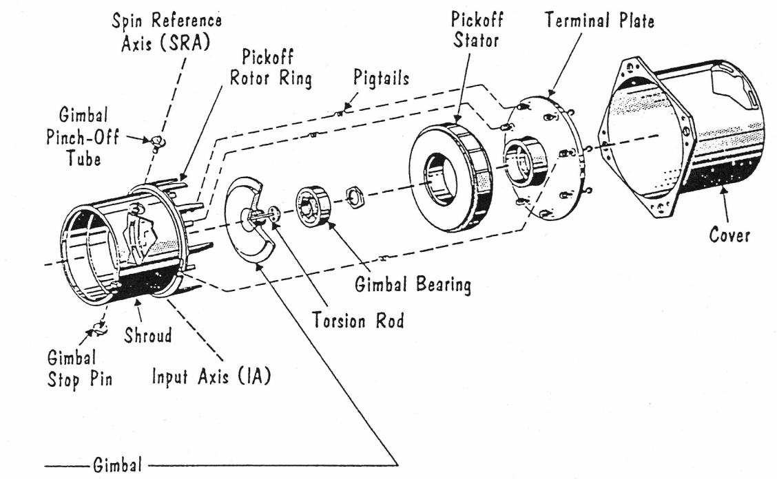
Fig. 6.
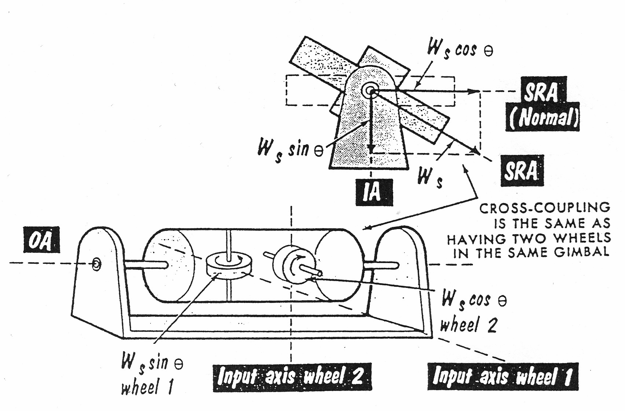
Fig. 7.

Text 3C. Compensated Roll Pendulum
Translate text 3C and put 3 special questions to its plot. Ask your
partner to answer them.
There is one variation of the rate gyro which looks something like the North seeking gyro compass. This is the compensated pendulum used to eliminate turn error in a vertical gyro. See Fig. 8. Instead of a spring restraint, the compensated pendulum uses a bottom heavy (pendulous) rotor. The spin axis is mounted along the aircraft pitch axis and the output axis is mounted along the aircraft roll axis. Therefore, the input axis is along the aircraft azimuth axis. When the plane is flying straight and level, the pendulous rotor acts like a plumb bob and lines up with the vertical. This provides the roll vertical reference for the vertical gyro.
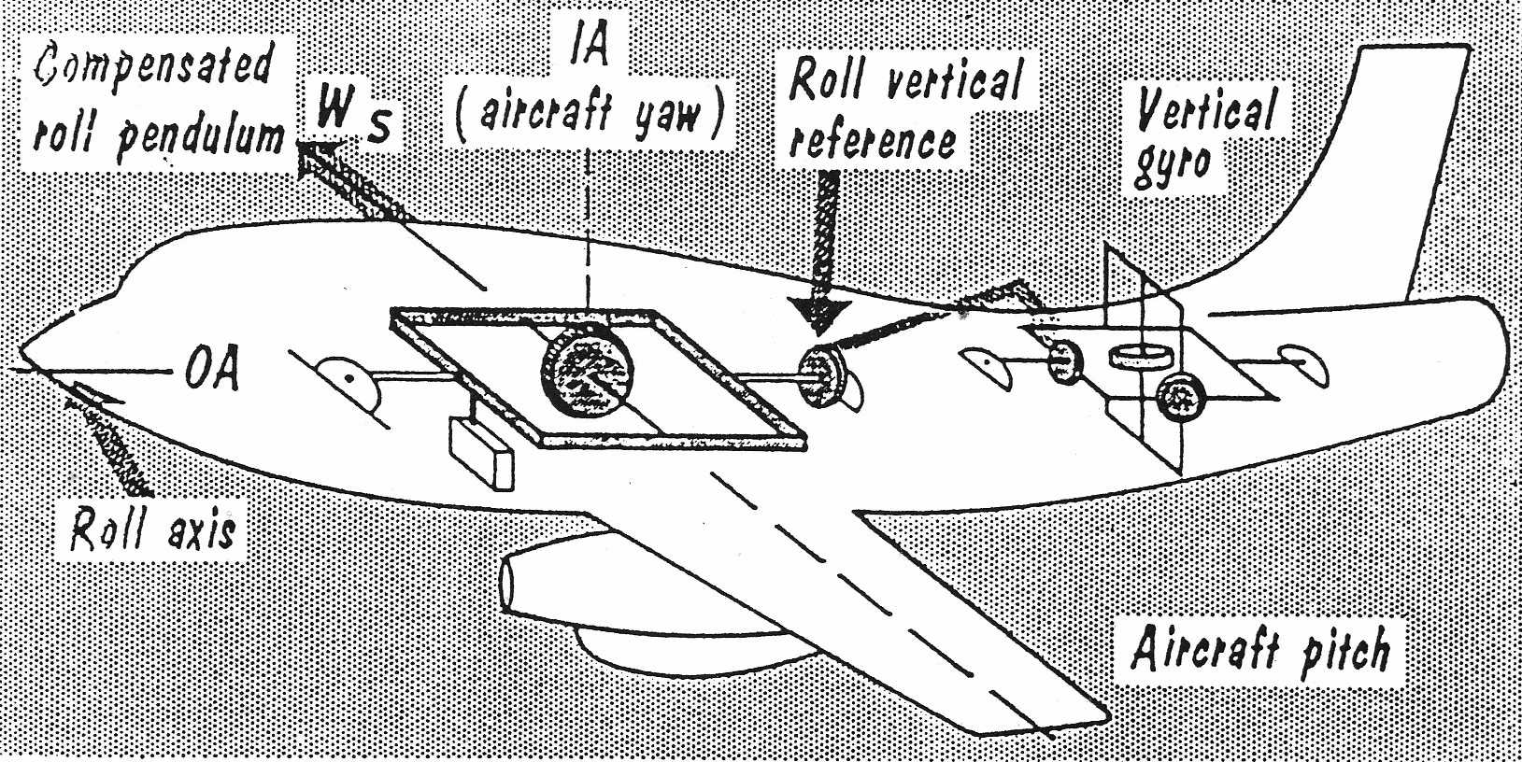
Fig. 8.
When the plane goes into a turn, the pendulous rotor tries to fly to the outside of the plane. This produces a torque about the output (roll) axis of the compensated pendulum. But an angular velocity is produced about the compensated pendulum input (azimuth) axis. Since the pendulum acts like a rate gyro, the angular velocity about the input axis develops a torque about the output axis. The spin vector is in such a direction that the gyroscopic torque due to turning is in an opposite direction from the torque trying to make the pendulous mass fly to the outside of the turn.
In the simple system described, the two torques exactly balance for only one air speed and the pendulum stays lined-up with the vertical during the turn. It is possible to design a much more elaborate system wherein the torques balance out for all values of airspeed. The more simple system, however, provides good turn compensation over the range of speeds the aircraft is likely to fly.

Exercises

EX.1. Answer the following questions.
- How does the change in temperature influence damping?
- What mechanical means have been devised to reduce the damping variation with temperature?
- What do these numbers in the text refer to: -5 deg F, 15 to 1, 5 per cent, +210 deg F, 4 to 1,10 to 1, +200 deg F, 4 times, 1.5 to 1.
- How can one reduce the damping variation with temperature?

EX.2. Translate into English, using the verbs with prepositions:
компенсировать, быть направленным на, подвергаться чему-либо, другими словами, вместо, быть пропорциональным чему-либо, для сравнения, вращаться вокруг, быть похожим на, при помощи, наполняться чем-либо.

EX.3. Translate the following word combinations:
gyro – captive gyro, rate gyro, displacement gyro, gyro precision, single – degree of freedom gyro, rate gyro motor, rate gyro output, gyro output signal, rate gyro natural frequency, rate gyro damping, fluid filled rate gyro
angular – angular displacement, angular rate output (input), input (output) angular rate, angular velocity
damp – damping – damping factor, particular underdamped case, damping gap, damped oscillation, damping fluid, damping characteristics
torque – torque in – precession out relationship, various controlling torques, random torque, torque input (output), stall torque
axis – quadrature axis, gimbal axis, input axis, output axis, spin reference axis, axis alignment, aircraft azimuth axis

EX.4. a) translate the following connecting words and adverbs:
therefore, in other words, by means of, providing, conversely, instead of, basically, to my mind, for some comparison, although, in the end, note that, usually, let us look at, for example, imagine that, since, as far as I know, to sum it up, generally, as, here, however, while, in turn, similarly, just like, suppose, at the same time, as a matter of fact, in my opinion, moreover, despite, thus;

EX.5. Try to remember the information given in the texts of Unit 1, 2 and 3.
- speak on displacement gyro and rate gyro in comparison. Try to use the expressions from exercise 7;
- define the figure of merit;
- speak on underdamped and overdamped systems;
- tell how we can check the accuracy of rate measurement in rate gyros;
- consider the statement: All fluid filled gyros compensate for the change in fluid volume with temperature. How can it be achieved?

EX.6. Translate the following sentences. Find infinitives and infinitive
constructions. Define their functions.
- The wheel exerts no direction torque or force on the object to be stabilized. 2. The second method of stabilizing the antenna is to mount it on a stable platform. 3. Wheel speed must be kept constant to keep angular momentum constant.4. To get 100 percent flotation in a reasonable size, it is necessary to use a very dense fluid. 5. To keep this system operating properly, the gyro torques must be extremely accurate. 6. Many years ago, gyro compasses were built for the Navy that had to have drift rates in the order of 0.02 to 0.04 deg/hr. 7. Although the gyro appears to be mounted rigidly in the metal gimbals, any metal structure has some lack of rigidity. 8. Non-isoelectricity causes the wheel to deflect along the line which is not coincident with the line of acceleration. 9. According to an Archimedean principle the force on a floating body is known to be equal to the weight of the liquid displaced. 10. Gyros from recovered missiles have been found to be in good working order. 11. One of the difficult problems to be solved was how to detect the position of the spinning sphere without introducing frictions or torques. 12. The most popular alternate construction to the conventional ball-bearing supported gyro is likely to be the single axis floated gyro developed by the Mass. Institute of Technology many years ago. 13. We know the vertical and directional gyros to be commonly called displacement gyros. 14. In this example the antenna is unlikely to be used as a stabilization reference for other equipment. 15. A gyroscope is still considered to be a mysterious instrument.

EX.7. Translate the following sentences paying attention to the underlined
connecting words.
- This problem becomes even more severe because of the particular damping fluids used with the integrating gyros. 2. Two integrating gyros are needed since each can stabilize about only 1 axis. 3. As long as the stabilized table is not rotating in inertial space, the gyro pickoff will have 0 outputs. 4. The integrating gyro cannot tell whether this torque about the output axis is coming from the torquer or from an angular velocity about the input axis. 5. Furthermore, the gimbal deflection of the spring restrained rate gyro will usually be less for a given input than the gimbal deflection of the integrating gyro. 6. Therefore, the inner gimbal and the rotor might be called stable platforms, stabilized about two axes. 7. But because the antenna is gimballed with the elevation axis connected to the airframe pitch axis the antenna elevation pickoff does measure the true aircraft pitch angle. At the same time, the antenna azimuth pickoff does not measure the true aircraft azimuth angle. 8. Since it is not easy, this kind of arrangements is avoided wherever possible. 9. Rather than have the roll gyro erect to the false vertical, a roll rate gyro is used to cut off the roll erection signal from the pendulum. 10. Compare this with the conventional autopilot displacement gyro which has a drift rate 300 times greater, even though H is 5 times larger. 11. With most radar antennas it does not make any difference if there is roll around the beam. 12. Whenever these pickoffs show a 0 signal the gimbal associated with that pickoff lies in the same plane as the vehicle carrying the platform.

SUPPLEMENTARY TEXTS FOR READING AND TRANSLATION
Text 1. The Earth is a Gyroscope
We have been concerned with the gyro as a transducer which provides an inertially stabilized reference line or plane for airborne stabilization applications. Let us note some other ways of applying the gyroscopic principle.
First, consider a really detailed situation. Did you know that you have been living on an enormous gyroscope? Our planet (some 8,000 mi in diameter and rotating once each 24 hours) is really a spinning rotor with an angular momentum of 0.53 times 10⁴⁰ gm-cm²/sec –a HIG-40, in other words. Because of this enormous H, the Earth for about as long as man knows, has maintained its axis pointing fairly well fixed in space within 1 deg of the North Star. The fact that the Earth's axis remains fixed in space, coupled with the rotation of the Earth about the Sun, explains the changes of season. Not only does the Earth keep its axis pointing in the same direction, it also exhibits typical gyroscopic precession. As a matter of fact, the word precession was derived from the motion of the Earth. A torque is applied to the Earth as a result of the gravitational pull of the Moon and, to a lesser extent, of the Sun. This torque tends to make the spinning axis of the Earth more perpendicular to its plane of motion around the Sun than it is. This produces a precession of the Earth's axis about an axis in quadrature to both the spin axis and the torque axis. The result is the Earth's axis has a conical motion – one complete cycle taking 26,000 years.

Text 2. Rifling
Let us take a look at the other end of the size scale – a rifle bullet. A gun barrel is rifled to give the bullet a spin in flight. In many types of projectiles the center of air resistance is forward of the center of gravity. This means that if nothing were done, a torque would be set up which could turn the bullet over in flight and make the tip face backward. With the spin resulting from rifling, the bullet acts like a small gyro and the angular momentum tends to resist the air resistance torque. Like any other gyro, though, the torque does produce a precession. It makes the bullet drift in azimuth. This drift is allowed for in sighting the gun. The larger the projectile, or the faster the spin, the less is the precession. There is nothing to sustain the spin throughout the entire flight against the friction drag of the air and the bullet spin rate slows down with increased range. If the air resistance torque does not reduce as quickly, the azimuth drift rate increases with range.

Text 3. Bikes, Hoops and Tops
One of the things that keeps you up on a bike is gyroscopic action. You unconsciously use the law of gyroscopic precession to right yourself, if the bike begins to tip. Suppose, for example, you were riding down the street with your hands off the handlebars, and your bike begins to tip over to the right. You might grab for the handlebar to turn the front wheel to the left. But that does not work. If you turn the wheel to the right, into the tipping direction, this action rights the bicycle. By turning the wheel to the right, it begins to precess about a horizontal axis (at right angles to the direction of spin). This is the correct way to restore the bike to an upright position. Centrifugal forces help too – but we are speaking about gyroscopes.
Remember the hoop and the spinning top? Both are kinds of gyroscopes. To turn the hoop, it did not do any good to try to push the back or front. This just caused the hoop to tip over. Instead, you tried to push the hoop over at the top of the rim. Spin vector into the torque vector, and the hoop turns by precessing about the vertical axis. When a top is slowed down, it does not just drop over. The spinning axis described a zone which slowly got flatter as the center of gravity descended. Precession came from a torque produced by the reaction forces at the tip, and the weight times the horizontal distance between the center of gravity and the tip.

Text 4. Ship Stabilizers
Let us look at some other ways that gyroscopes have been used. To reduce a ship's rolling one should use a gyroscope as a brute force ship stabilizer. This is basically a single-degree-of-freedom gyro with the spin axis vertical and gimbal axis along the athwartship axis of the boat. Suppose the boat starts to roll. This means that a torque is being applied about the fore-aft axis of the ship, in quadrature to both the spin axis and the gimbal axis. At the same time, gyroscopic torque is developed about the fore-aft axis which opposes the force producing the roll. The gyroscopic torque will continue to oppose the rolling torque until the gyro precesses so that the spin axis aligns with the ship's roll axis. At this point, the gyro ceases to act as a roll stabilizer. This system would work fine if all stray torques were eliminated so that the gyro would not drift; and if all rolling torques were of such magnitude and duration, and also symmetrical, so that the spin axis would never precess to be in alignment with the ship's fore-aft axis. These necessary conditions make it impossible to use an uncontrolled gyro.
There is another way. The rolling motion of the ship can be detected by a smaller single-degree-of-freedom control gyro mounted so that the spin axis is along the ship's athwartship axis and the gimbal axis is along the vertical axis. The stabilizing gyro is mounted as before, except that a small torque motor has been added which is geared to exert torque about the gimbal axis of the big gyro. This torquing arrangement is really very much the same as used in the centering system of a stable platform. When the ship rolls, the control gyro precesses about the vertical axis and contacts are closed which start the precession motor. The motor torques the big gyro around the gimbal axis which is the same as the ship's athwartship axis. Law of gyroscopics, and the big gyro begins to precess about the roll axis of the ship in such a way as to counteract the roll motion which the control gyro detected. With this control gyro method it is possible to overcome the difficulties encountered by using a brute force gyro for stabilization. These stabilizing gyros come big-some more than twice as tall as a man and weighing about 100 tons. Units this size are for an ocean liner, generally.

Text 5. Gyrostabilized Cars
There were some efforts early in the 20th century to apply gyroscopes to land vehicles. In 1905, Louis Brennan of England invented a monorail car, held in dynamic equilibrium by gyroscopes. Early models used a single gyroscope, with the spin axis horizontal. A tiller was used to torque, the gyro about a vertical axis and the resulting precession about the fore-aft axis of the car was sufficient to keep the vehicle upright. This was alright as long as the car went in a straight line. When the track curved, however, centrifugal forces acted against the gyroscopic forces and the car became unstable. To overcome this difficulty, Brennan used two similar rotors mounted side-by-side which rotated at the same speed but in the opposite direction. The gimbals were geared together for control purposes. When the car turned, the precession torques of the two gyros opposed each other and the car would turn without difficulty. August Scherl of Germany and P. P. Schilowsky of Russia also produced monorail cars during this same period. A gyroscopically stabilized two wheel automobile, of experimental importance, was produced in England in 1914 but it was not a commercial success.

Text 6. Binocular Stabilizer
Another application of the gyroscope is as a binocular stabilizer. Most of us are nervous. This is not a problem, except when we are trying to use high power binoculars (about 7 times 35 or stronger). Then these natural motions of our hands, trying to support the binoculars, are enough to seriously blur the image. The problem is especially acute when one tries to use binoculars on a moving vehicle such as a boat. Gadgets have been marketed which attach to the glasses and work like a ship stabilizer. In the construction of one binocular stabilizer two single-degree-of-freedom gyros are contained in a cylinder attached to the binoculars. Both wheels have the spin axis vertical, but one rotor has freedom about the forward looking axis and the other has freedom about the transverse axis. The gimbal bearings are fine wires instead of ball bearings. These wires tend to center the rotors. Let us look at the gyro with freedom about the forward looking axis. If the binoculars try to move about the transverse axis (which would be an elevation or depression of the glasses), the transverse gyro will precess about the forward looking axis and will, during this precession, exert a torque about the transverse axis which will cancel out the external torque trying to produce the motion. The forward gyro works the same way in cancelling out motion about the forward looking axis. This same principle of stabilization has been used to steady hand held sextants used for navigation aboard ships. All of the gyro constructions used for direct stabilization have one feature in common: the rotor is free to precess about an axis in quadrature to the stabilization axis. As a matter of fact, some of the early gyro experimenters did not provide this precession freedom and their stabilization devices did not work one bit. Why the freedom? Go back to the law of gyroscopics: T equals H W_{p}. If the gyro is locked in place, it means that W_{p} equals 0. Therefore, T, the stabilizing torque, must be 0, and the gyro exerts no stabilizing force.

Text 7. Integrating Accelerometer
The gyroscopic principle has been used to build a very accurate integrating accelerometer. Remember, integrate means to sum up. An integrating accelerometer sums up accelerations and therefore measures velocity.
A configuration like the integrating gyro is used, except that the gimbal is made pendulous along the spin axis by making the gimbal unbalanced. The gyro case is mounted on a table which can be rotated about the gyro input axis. Suppose the structure is accelerated along the gyro input axis. The gimbal unbalance sets up a torque about the gyro output axis and, due to bearing loads, the gyro starts to precess about the output axis. This precession is detected by the pickoff on the output axis and an error signal is produced which drives a servo-motor through a servo-amplifier. In turn, the servo motor drives the table on which the gyro case is mounted at an angular rate about the input axis, just fast enough to produce a second torque about the gyro output axis which balances out the torque produced by the acceleration. Since the angular rate at which the gyro is moving about the input axis is proportional to the linear acceleration along the input axis, the total angle through which the gyro rotates about the input axis is proportional to the linear velocity along the input axis. The output of the pickoff mounted along the input axis between the table and the base surface is a measure of the linear velocity along the input axis.

Text 8. Direction Finders
Gyroscopes have been used in various forms as direction finders. Compact two degree-of-freedom gyros have been used to provide a stabilized line-of-sight for surveying oil wells. Most of us think that oil wells are drilled straight down, but often this is not the case. In offshore drilling, for example, the rig is located on the shoreline and the drill is angled off under the bed of the body of water. Periodically, a gyro is dropped down the drill shaft and measurements are obtained of the hole direction. By monitoring the changes in hole orientation, and by knowing the depth to which the gyro has been dropped, it is possible to plot the course of the drilling. Occasionally it is necessary to drill at an oblique angle in order to tap an oil pool located under a rock shelf and this also requires an accurate determination of the drilling direction.
Incidentally, boring direction is changed by changing the drill bit speed. A field-use direction finder can replace conventional surveying, celestial and magnetic methods of establishing a highly accurate azimuth reference base line. Celestial methods require star fixes and can be used only at night. Magnetic methods are involved since magnetic North must be determined before true North can be established. The field-use direction finder employs a highly sensitive rate gyro to monitor the Earth's rotation. The rate gyro is adjusted until its input axis is perpendicular to the axis of the Earth's rotation. This is the point at which the rate gyro output is minimum. If the input axis of the gyro is horizontal at the same time, the axis must be parallel to a true East West line. Once a true East West line is established, any other required direction can be found.

Text 9. Remember Gyroscopics
Gyros have been used as computing elements for aircraft gun sights. They have been used to control torpedos. They controlled the buzz-bombs of World War II. They were used as an artificial horizon in marine navigation by an Englishman over 200 years ago. They stabilize naval and tank gunfire. The principles of gyroscopics must be kept in mind by the designers of automobiles and jet engines because of the large gyroscopic effect of the flywheels on the bearing supports.
One tragic consequence of failing to account for gyroscopic precession occurred during World War II. The propellers on an airplane act like a pretty big gyro rotor. On American planes, the propellers rotate clockwise as viewed by the pilot. Consider what happens when the pilot wants to bank to the right. As a result of propeller rotation, a gyroscopic torque is produced about the plane's pitch axis, which tends to depress the nose.
Now this is something each American pilot becomes familiar with and so he automatically compensates by pulling the joy stick back to produce an opposing torque and keep the plane level. But now the problem. It is conventional on British aircraft for the propellers to rotate in the opposite or counter-clockwise direction. This means that in a right turn, the British pilot learns to push the control stick forward to keep the nose down. Early in World War II, when British pilots came here to ferry back American planes, there occurred a rash of unexplained crashes. The explanation is that British pilots would execute a right turn in an American plane. Out of habit, they would push the control stick forward to keep the nose down. But in American planes, gyroscopic torque from the propellers would also be tending to push the nose down in a right turn, and the pilots were flying their planes into the ground.

QUESTIONS AND PROBLEMS
1. Why is the Earth like a gyroscope?
2. Why is a rifle bullet rifled?
3. Show by sketch why a hoop turns when you press on the top.
4. Explain why any brute force stabilizing gyro must have freedom to precess.
5. What did Brennan, Scherl and Schilowsky have in common?
6. How will the binocular stabilizer react to rapid twisting motions of the viewer?
7. Sketch an integrating accelerometer using a gyroscope.
8. What does the output pickoff of the integrating accelerometer measure?
9. Explain briefly the operation of the field-use direction finder.

